ARTFULL - THREE WAYS CATALOGUE
Victoria Dowall
- Pink and Purple Putiputi acrylic on stretched canvas $450
- Moonlight Putiputi acrylic on stretched canvas $400
- Papatūānuku acrylic on stretched canvas $200
- Pretty Putiputi acrylic on stretched canvas $220
- Putiputi Purple Season acrylic on stretched canvas $400
- Māwhero to Kahurangi acrylic on stretched canvas $250
- Iti Putiputi Tahi acrylic on stretched canvas framed in pine wood $160
- Iti Putiputi Rua acrylic on stretched canvas framed in pine wood $160
Alison Lowe
- Dancing Queen Medium Mixed $475
- Surf’s Up Medium Mixed $475
- Ka Boom Medium Mixed $475
- Medieval Village Medium Mixed $475
- Head of the Herd Medium Mixed $475
- Meandering Medium Mixed $475
- Vitality Medium Mixed $475
Anna Coursey
- Midnight Hydrangeas oil on canvas $590
- Midnight Roses oil on canvas $590
- Winter Bloom oil on canvas $950
- Daisy Splash No. 1 oil on canvas $200
- Daisy Splash No. 2 oil on board $125
- Shadows oil on canvas $540
- Blooming oil on canvas $440
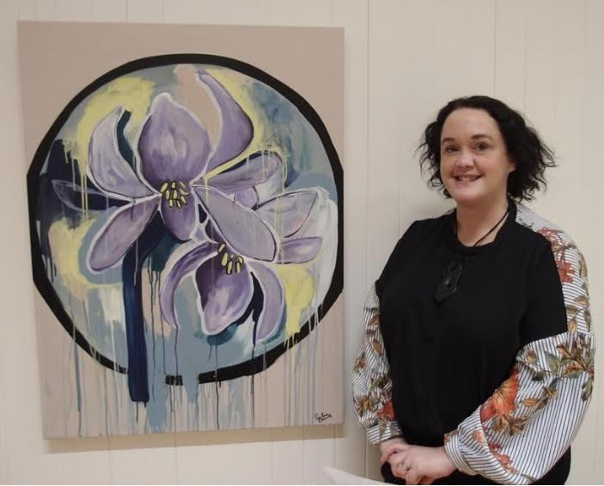
VICTORIA DOWALL
I love using bright acrylic colours from the Resene range. My marks are expressive mixed with simple lines. I love paint drips and their emotional and unpredictable nature. Painting on black gives the impression of things coming out of the darkness. My main subject matter are kanohi (faces), putiputi (flowers), and whenua (landscapes). Painting is a cathartic experience for me. A time I can reflect, problem solve and feel successful.
I have exhibited at the Kaiapoi Expo, Oxford Gallery Toi o Waimakariri, Eastside Gallery, Selwyn Arts Heart, Arts Canterbury Expos, Back Wall Gallery at the Amberley Library, New Brighton Gallery, LEStrange Gallery and Down at the Liffey Gallery.

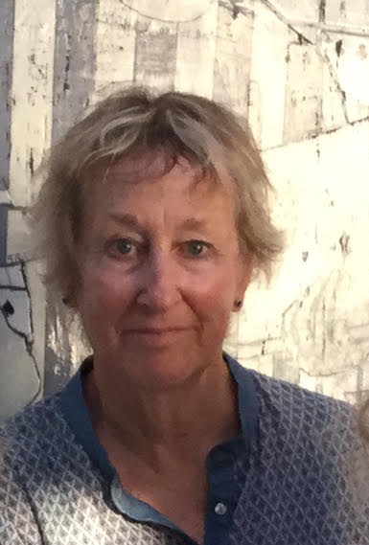
ALISON LOWE
Alison’s artwork is pretty much anchored in the realm of abstraction and the enjoyment
and satisfaction of not knowing what the end result will be. Acrylic paints and inks, collage, oil sticks, and pastels are used on canvas which is then stretched and cradle framed. A painting will evolve as an exciting, experimental exploration of dynamic colour combos and textural gestures.
There is a constant layering and overlapping going on ….. there’s never a dull day in the studio.
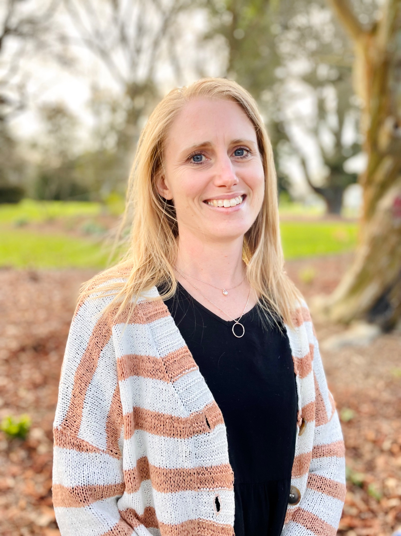
ANNA COURSEY
My name is Anna Coursey. I have always loved painting, I considered a career in art but instead pursued a career in nursing. Now juggling family life with 3 daughters I am having a break from nursing and returning to my love for art. Originally from Christchurch, I moved with our family to Lincoln nearly 2 years ago.
My creativity sparked once we moved here and I have been enjoying my creative space in my home studio. I started experimenting with portraits, still life and abstract pieces as I searched for my own style as an artist. My garden has given me so much inspiration which you can see in this series of works. I love exploring colour, shape and light in nature, moving from realism to a more abstract expressionist style. I am mostly a self- taught artist. I paint using oils on canvas or board. I love the nature of oil paint - how it blends, how it dries and the vibrancy of the colours. This is my first exhibition as an emerging local artist. I hope you enjoy it!

