Wild and Whimsical
Elizabeth Rosa
- Bloom 91x61cm Acrylic on Canvas $1950
- Blaze 91x61cm Acrylic on Canvas $1950
- Convivial 91x61cm Acrylic on Canvas $1950
- Azure 91x61cm Acrylic on Canvas $1950
- Gelid 91x61cm Acrylic on Canvas $1950
- Verdant 91x61cm Acrylic on Canvas $1950
- Aureate 91x61cm Acrylic on Canvas $1950
- Where do the wild korimako rule? 50cm round Acrylic on Board $770
- Reign in the Winter Acrylic on Canvas $970
- Tieke 20cm round Acrylic on board $180
- Ruru 20cm round Acrylic on board $180
- Bellbird 20cm round Acrylic on board $180
- Kea 20cm round Acrylic on board $180
Eszter Luca
- Kingfisher 10cm round Acrylic on Acacia Wood $120
- Kokako 10cm round Acrylic on Acacia Wood $120
- Kakapo 10cm round Acrylic on Acacia Wood $120
- Harakeke Garden 20cm round Acrylic on board $250
- Fuchsia Garden 20cm round Acrylic on board $250
- Kowhai Garden 30cm round Acrylic on board $550
- Pohutukawa Garden 40cm round Acrylic on board $850
- Manuka Garden 60cm round Acrylic on board $1900
- Karaka Garden 60cm round Acrylic on board $1900
- Golden Garden 90cm round Acrylic on board $3250

Elizabeth Rosa
Masters Degree in Engineering

Elizabeth Rosa, based in Christchurch New Zealand, creates bold artwork portraying the beauty found in the natural environment of Aotearoa. Elizabeth has a masters degree in engineering from the University of Canterbury, but has built her art practice in Otautahi, Christchurch over the last four years, after returning from overseas.
Elizabeth's work portrays the abundance of colour and light that found in our native fauna and flora. Her recent work has focused on the native birds of Aotearoa. Although the birdlife can look muted, there is always an abundance of colour when captured in the right light. Elizabeth aims to give personality and attitude to the birds by depicting them in a way that makes the life of the bird central to the scene. Her paintings portray a sense of regality in the painting - the native Fauna of New Zealand do not exist in our world, we exist in theirs.

www.elizabethrosaart.com

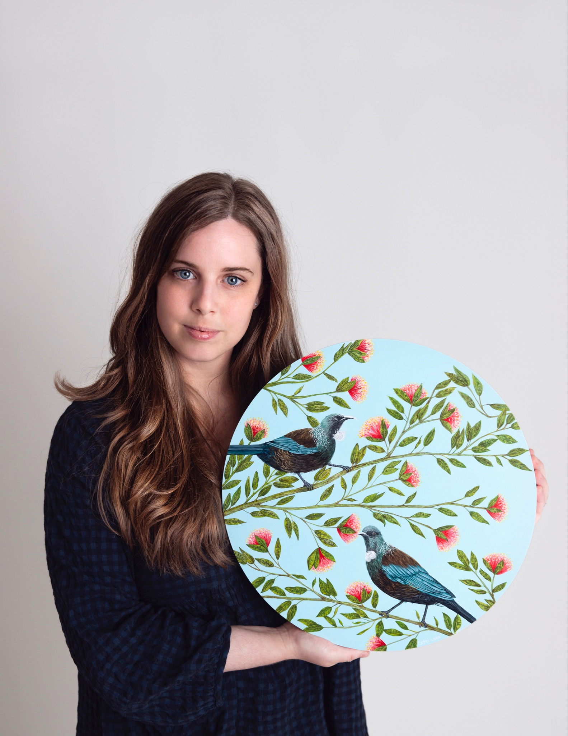
Eszter Luca
Bachelor of Arts and Media
Diploma in Interior Design
Graduate Diploma in Teaching (Art/Art History)

Artist Eszter Luca is based in the beautiful Garden City known as Christchurch, New Zealand. There you will find her painting away most days, pouring her heart into her canvas to create statement artworks for you to treasure for years to come.
Eszter specializes in creating unique original artworks and commissions for your home and office, drawing from her experience of working within the Interior Design Industry.

This collection of works showcases and explores the beauty of our natural world in colour that is vibrant and bold, creating striking works that bring attention to how our native birds and flora need to be protected and conserved. Inspired by the idea of native birds, gardens and forests, each piece aims to transport you to a garden or forest with a particular native bird and native flora.
www.eszterlucaart.co.nz

LCN ARTICLE:
The latest exhibition at Down by the Liffey Gallery is sure to impress! ‘Wild and Whimsical’ is on display from Wednesday October 12th 2022 until Sunday November 13th 2022, featuring Artists Elizabeth Rosa and Eszter Luca.
This exhibition is beautifully curated, with both artists' works complementary to one another's. Each artist has a theme of Native New Zealand birds and Flora, and each artist has beautiful bold colours sure to capture your attention, making a lovely addition to your own art collection in your home or office! Each artist undertakes their subject matter in a unique way, creating fresh works that are each beautifully painted and a real work of art!
Eszter Luca’s work is incredibly detailed, with native birds in native forests, and you are bound to continue finding new details in her work the more you look at it. Her works consist of 7 paintings, ranging from her largest centerpiece being 90cm in size, to her smallest at 20cm. Her largest in the center is a statement piece, with hints of gold, as you walk around it the light captures it and it shimmers creating a truly unique work of art. This artwork also features the Huia which is an incredibly special and beautiful Native bird that is extinct in New Zealand, making this artwork extra special.
Eszter Luca is based in the beautiful Garden City known as Christchurch, New Zealand. There you will find her painting away most days, pouring her heart into her canvas to create statement artworks for you to treasure for years to come. Eszter has a Bachelor of Arts and Media, a Diploma in Interior Design and a Graduate Diploma in Teaching (Art/Art History) all of which has contributed toward her career as an artist. Eszter specializes in creating unique original artworks and commissions for your home and office, drawing from her experience of working within the Interior Design Industry.

Eszter says ‘This collection of works showcases and explores the beauty of our natural world in colour that is vibrant and bold, creating striking works that bring attention to how our native birds and flora need to be protected and conserved. Inspired by the idea of native birds, gardens and forests, each piece aims to transport you to a garden or forest with a particular native bird and native flora.’
Elizabeth Rosa’s works are lovely and depict portraits of birds with flower crowns in a beautiful regal manner. Her paintings has beautiful feathering within the birds feathers and the variety of eye catching colours that you will find within each bird. Her main body of works depict 7 large paintings each measuring 61x91cm in size, and each bird standing strong with confidence. These larger paintings are accompanied by some smaller pieces depicting birds, the smallest in size being 20cm.
Elizabeth Rosa, based in Christchurch New Zealand, creates bold artwork portraying the beauty found in the natural environment of Aotearoa. Elizabeth has a masters degree in engineering from the University of Canterbury, but has built her art practice in Otautahi, Christchurch over the last four years, after returning from overseas.
Elizabeth's work portrays the abundance of colour and light that is found in our native fauna and flora. Her recent work has focused on the native birds of Aotearoa. Although the birdlife can look muted, there is always an abundance of colour when captured in the right light. Elizabeth aims to give personality and attitude to the birds by depicting them in a way that makes the life of the bird central to the scene. Her paintings portray a sense of regality in the painting - the native Fauna of New Zealand do not exist in our world, we exist in theirs.
This is an exciting exhibition with beautiful artworks, so you certainly don’t want to miss out on the chance to own or see these original paintings in person!
www.elizabethrosaart.com
www.eszterlucaart.co.nz

