A Striking Sight

Lisa Banks
- Sea Meets Land Oil on Canvas, framed by Ciaran Banks $950
- Stranded Acrylic on art paper $500
- Stormy Harbour Oil on canvas $450
- Stuck on Shore Oil on canvas $650
- Harbour & Boats Mixed media on art paper $400
- Sky Meets Sea Oil on Canvas Board $390
- Sea and Headland Oil on Art Paper $350
- Sennen Cove Oil on Art Paper $150
- Stormy Sea Oil on Art Paper $150
- Dark Sea Oil on board $150
- Leaving Takaka Oil on Canvas $350
- The Lighthouse Print 1 of 1 $300
Jennifer K Shields
- Horowhenua Silver gelatin print $200
- Trametes II Silver gelatin print $200
- Maunga II Silver gelatin print 8x10" $200
- Library Silver gelatin print 8x10" $200
Cosette Calder
Dreamtime Series
- Fire Acrylic & Silver Leaf on canvas $325
- Lagoon Acrylic on canvas $275
- When the rains came Acrylic & Gold Leaf on canvas $125
Coastal Series
- Oceans 1 Acrylic & Gold Leaf on canvas $325
- Oceans 2 Acrylic & Gold Leaf on canvas $175
Jewel Series
- Decadence Acrylic & Gold Leaf on canvas $325
- Jewel 1 Acrylic on canvas $155
- Jewel 2 Acrylic on canvas $215

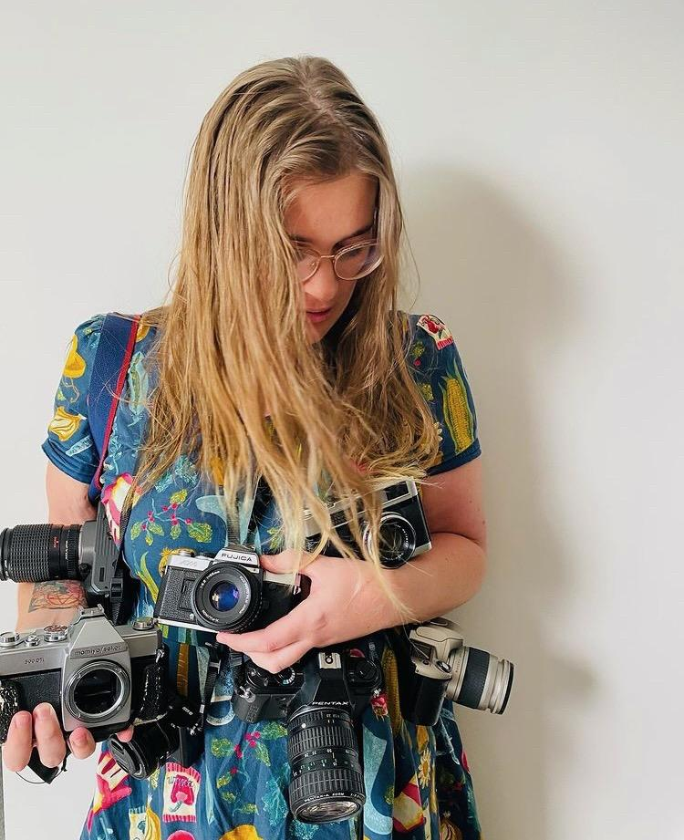
Jennifer K Shields
Jennifer K Shields is a film and digital photographer from Ōtautahi, Aotearoa. She’s had a passion for taking photos since she was in high school, breaking lenses in cul de sacs on shoots. Both her grandparents were avid photographers, and on mentioning her interest in film photography over Christmas 2020, her grandmother gave her a Canon EOS 300 to get started. In the six months following, her film camera collection grew to 10. Her current work deals with nostalgia and the blend of analogue and digital approaches to photography, in both black and white and colour. She often prints her own works in a hallway darkroom, fitted sheets stretched over closed doors to keep out the light. Works in A Striking Sight have been taken in Ōtautahi, Staveley, and Tāmaki Makaurau over the last year.

Lisa Banks
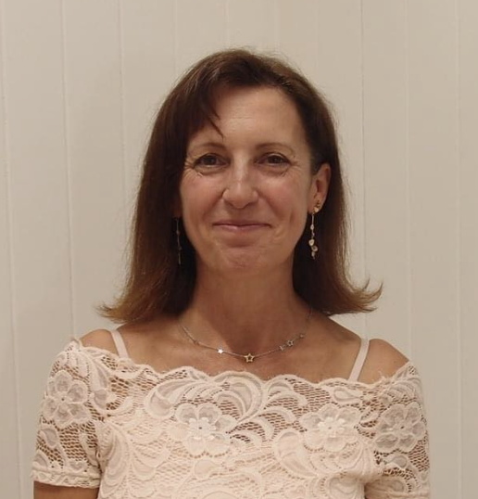
When I am not painting, I work on the water with boats. I tie lines, make fast, check lines and moorings. The time I spend on the water gazing at the sea and the shape and form of boats, informs and influences everything I paint. The colours, the movement, rising tides and super low tides, change how boats sit especially when anchored. This seeps through to my work. I am particularly fascinated by buoys and lines and the patterns they make.I love to use oils as they move freely in the same way the sea does. I then add charcoal and use oil sticks to play with the shape that the lines make as they intersect harbours and cut across other boats in their effort to stay tight. My work has been moving further into abstraction as I try to capture this story. I also love to paint the sea and waves. The movement of clouds and the colour changes where the ocean meets the sky are particularly fascinating. How many blues are there? I spend much of my time in Lyttelton and Akaroa where the water is murky and the sky bright. I also go to St Ives in Cornwall once a year, where the sea is crystal clear and the sky cloudy. In both places there are cute fishing boats, sailing boats and dinghies. I find all of them beautiful and am endlessly fascinated by their shapes.

Cosette Calder
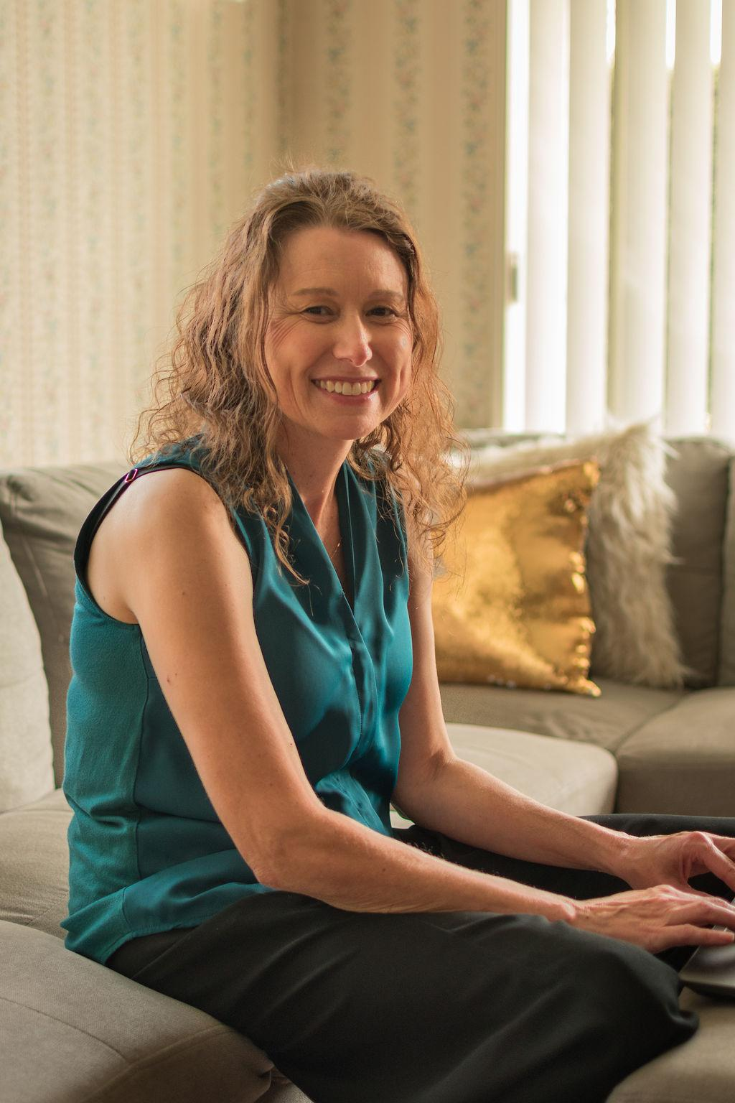
Cosette is originally from Australia. Her childhood and teens were spent in small rural townships across Victoria. Early life was spent exploring the outdoors. In 1994 at age 18 she made the move to Timaru, New Zealand. Enrolling at Aoraki Polytechnic she studied first year Foundation Visual Arts. Following on from that she completed a second year of Fine Arts painting in 95. Cosette is currently residing in Christchurch with her teenage son. She spends her time exploring the Arts, painting, acting, reading books, playing Tennis and walking the Port hills. Cosette is also an 8 year cancer survivor. Following her creative passion Cosette spent last Summer painting. Historically an oils painter Cosette instead explored Acrylics, gold and silver leaf and different application techniques. The Summer 22/23 works consists of three series Coastal, Dreamtime and Jewel. Jewel series celebrates the richness of Jewel tones. Decadence is the first painting in the series and encompasses cerise, golds and forest greens with hints of gold leaf. The Coastal series was inspired by the New Zealand beaches and an awareness of looking after our oceans and the environmental impacts on our seas, our love of the beaches and the beauty of the landscape in New Zealand. Dreamtime series envisions and represents Australia when it was first created. Memories of much needed rain and the threat of bushfire come through in abstract form. Remembering and celebrating this ruggedly beautiful and dry land was the inspiration for this series and her roots in Australia. Artistic influencers include Vincent Van Gogh, Gustav Klimt, Edouard Manet and Jackson Pollock amongst many others. Cosette enjoys freedom of expression and colour with her mixed media painting.

